# NETSCAPES REPORT

## INSIGHT: The Big FIVE

Group

Gintare Gruzinskaite, Stephanie Field (10468133), Christopher Maycock (10499726)

## Introduction

[100 - 150 words]

The practical and theoretical aim of the project was to externalise, through simple data visualisation, an individual user’s personality, using the five factor model of personality traits, otherwise known as the CANOE/ OCEAN Model. This would be interactive and immersive, allowing an individual user to input their own data and affect the outcome of the live visualisation. The group wanted to create a Meta environment of the CANOE model that the user can experience. We felt the objective of our concept was important in so much as the personality is a complex structure and we wanted to open up the idea of personality interpretation.

The realisation of the project was to build an interactive housing for the electronics, a working in/out MongoDB and a working visualisation of the database inputs.

## Background

[300 words]

Our early research into finding a suitable model of the human condition began by exploring Maslow's Hierarchy of Needs and how we could determine values from that system.

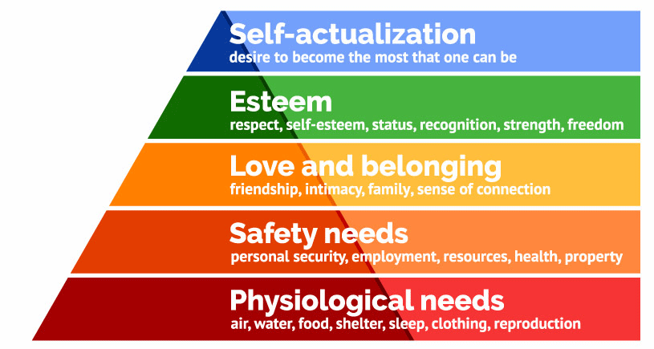

Maslow Model of Hierarchy Needs (Simply Psychology, 2018).

Whilst delving into how we could represent our user’s data in a way that fitted our desired outcome, we drew an end to exploring this method as it was framed in a way that determines the needs of an individual rather than a personality model. We also explored the idea of making a small community of robots that used the individual strata of needs to operate but the module timescale meant we terminated the idea. This early research stage then led the team towards a personality model. We uncovered a model that used the acronym CANOE which what is referred to as the “big five”. This model is known as Five Factor Model (FFM).

The five characteristics are:

* Openness
* Conscientiousness
* Extraversion
* Agreeableness
* Neuroticism

After exploring the idea of how we could realise an installation that “Not as much explained personality but described traits” (to paraphrase the website emaze.com) we researched some online personality tests to see how their results might be translated into an abstract visual.

### Online assessment of personality types.

<http://www.personalitytest.org.uk/>

<https://www.truity.com/test/big-five-personality-test>

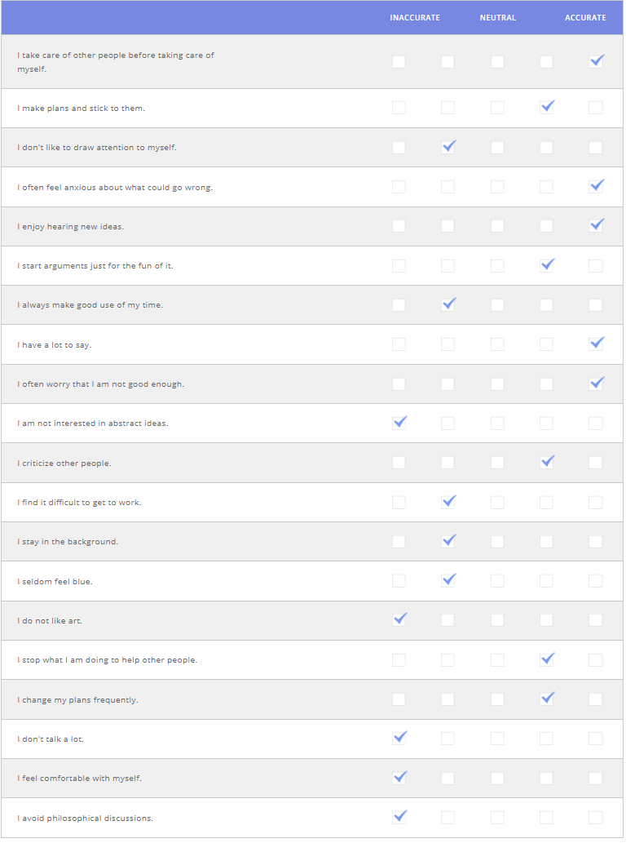

Example of online of Chris Maycock CANOE model test (Truity.com, 2018)

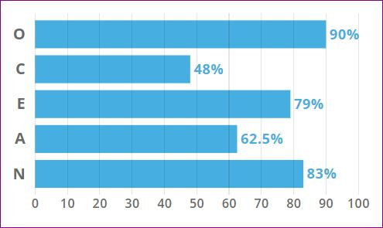

Chris Maycock OCEAN/ CANOE assessment results output (Truity.com, 2018)

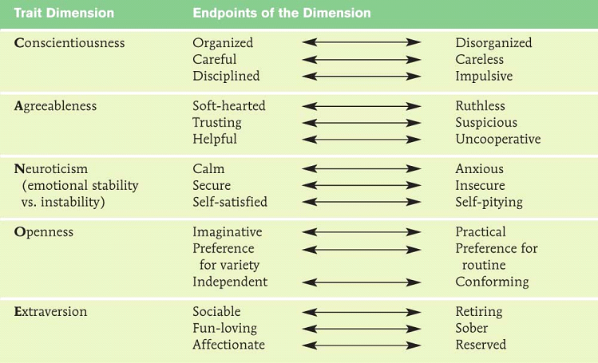

Scale-able CANOE model (emaze presentations, 2018)

It was from these early researches that we decided to change statistical data into something of a more abstract nature.

## Visualisation research

It was through researching how to visualise data in an abstract manner that we decided to bring the two ideas of circles and inputs together; such as changing values of the circles drawn within our own visualisations. We tested some projected shapes in the Immersive Vision Theatre (IVT) to see how they rendered within the dome environment.

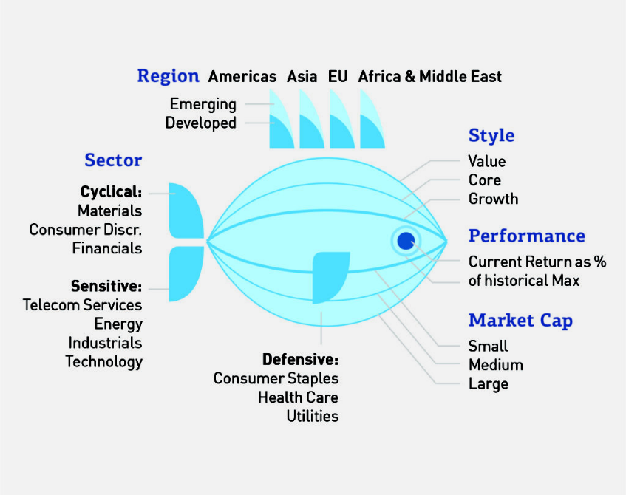

One of our inspirations for the visualisation Data personality: evaluation. (Information Age, 2018)

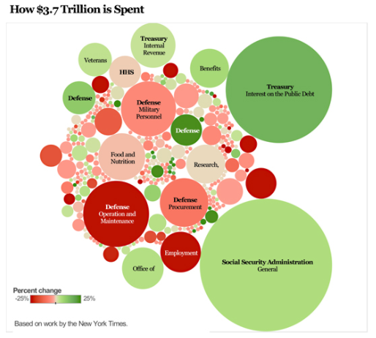

Using circles of varying diameters to present data ([www.sisense.com](http://www.sisense.com))

The use of circles prevents the infringement of mapping calculations and noticeable domic projective distortions that other shapes within the IVT created, thus we could present our visual abstraction without distraction from the immersive experience

## Methodology

[300 words]

We began by working out a basic system for the project overall which aimed at drawing a visualisation based on real user data input within an installation.

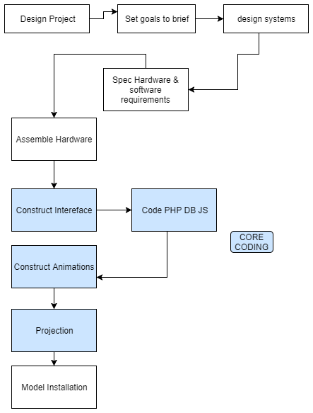

Overall system diagram to realise the project’s completion (Chris Maycock)

Later in the process of working out how the systems could deliver a visual abstraction, the group drew up how the interface and the visualisation might operate together.

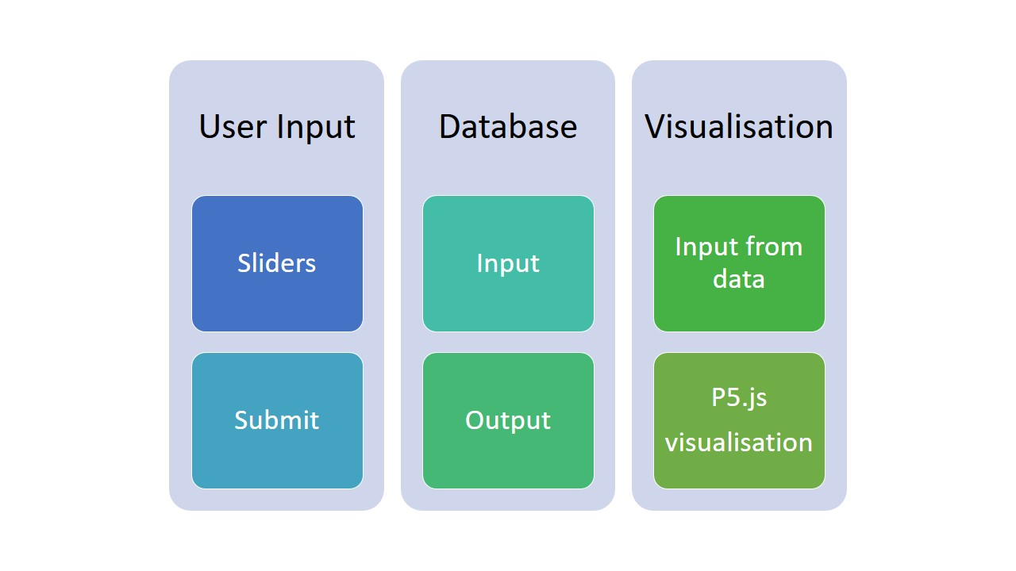

Visualisation system diagram of processes (Chris Maycock)

For the database we chose MongoDB and mLabs as a way of handling user inputted data, from this data base natural numbers would be parsed into the parameters and mapped within the p5.js code for RGB values, size and position.

### Head and Base

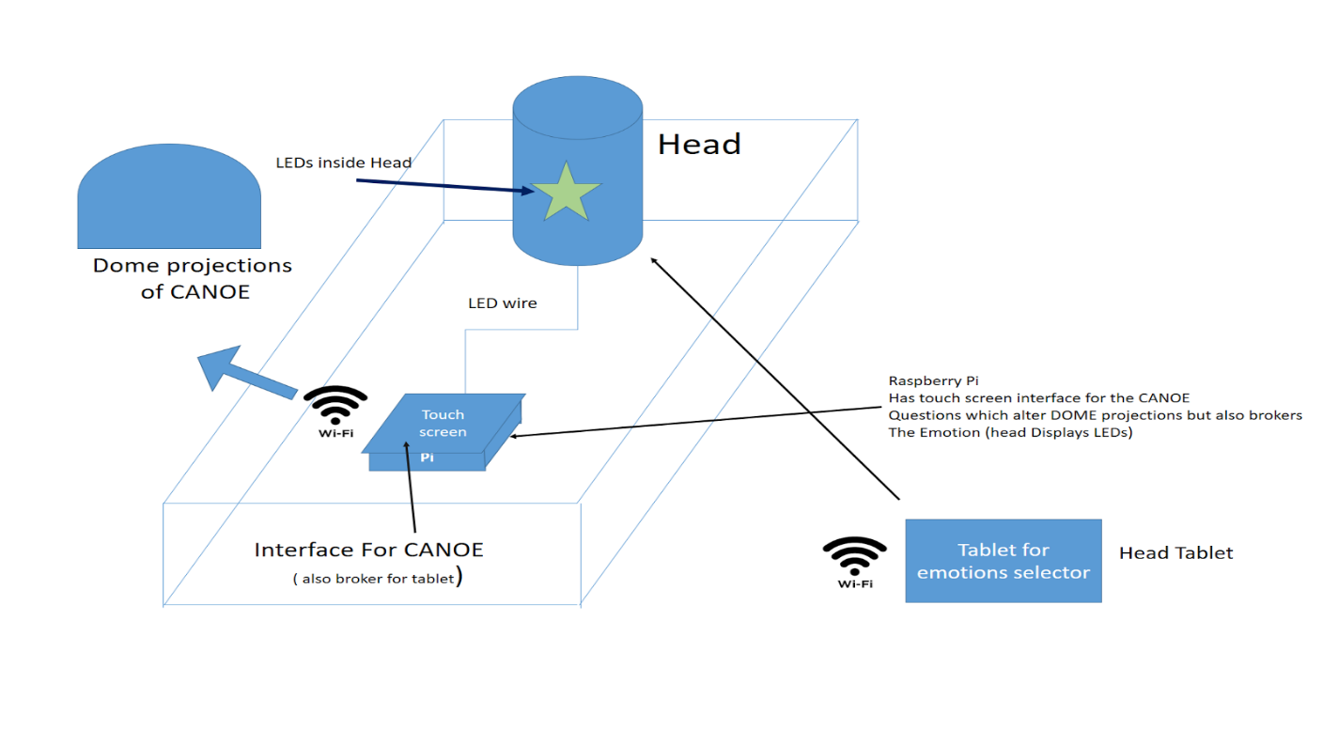

System diagram of Installation (Chris Maycock 2017)

### User Interface

After prototyping 3 LEDs inside the glass head with an Arduino Uno, as a lighted feature, two changes were made: a light diffuser was designed via CAD and 3D printed to go inside the glass head and fixing a Neopixel 24 LED inside the base increased illumination and lighting effects. The desired results were achieved of multi light effects to draw users to the interface.

HC-05 Bluetooth Module was married to Arduino Uno that drove the LED Ring to offer colour changes inside the head. A simple console app on an android phone was used to set the LED ring state.

### Back End

Whilst creating our database connections, we switched between different database types.

Part way through, we decided to switch from MongoDB to mySQL because of difficulties connecting the visualisation to mLab. Stephanie set up a database on her remote server temporarily - originally this was intended to be a MongoDB database, but due to incompatibilities with the server software we switched to mySQL. To fulfil the ‘cutting-edge’ technologies requirement of the brief, we later switched back to using MongoDB and mLab,which was succesful.

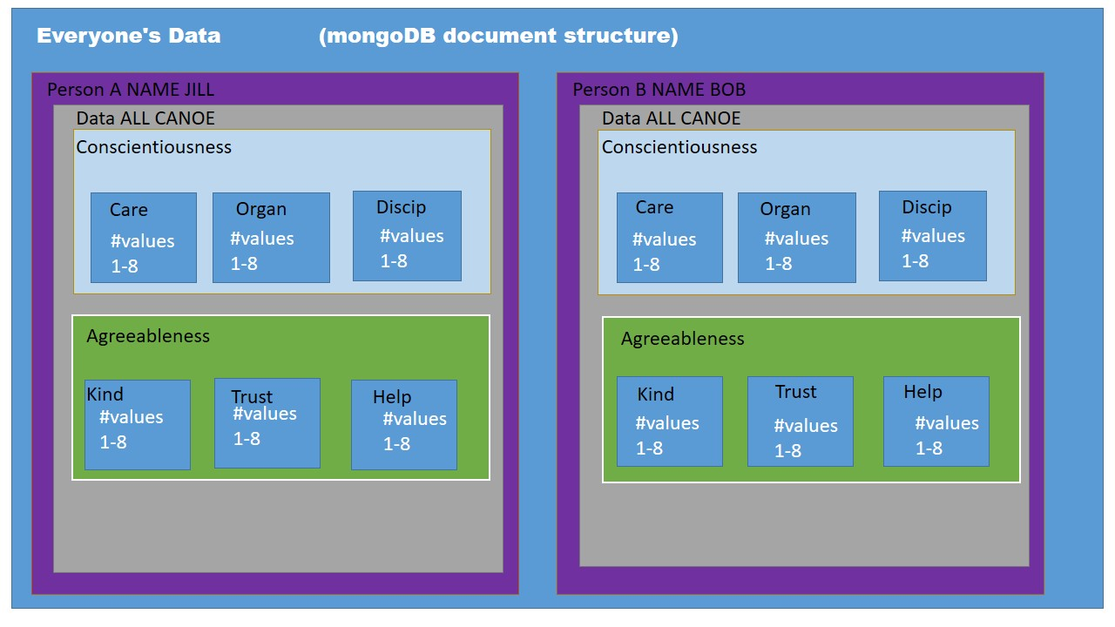

Mongo DB Document layout (Chris Maycock & Stephanie Field)

### Animation

For the animation Gintare used p5.js. JavaScript library which is very similar to Processing, the main difference between the two is that P5 is a direct JS port of the Processing language. Processing.js is a converter which interprets pure Processing code into JS on the fly (SitePoint, 2018). Gintare had some previous experience working with Processing since they both work on the same principles, it was relatively easy to learn a new library. As for the animation itself, Gintare researched code from the codepen.io and carried out some tweaking in order to get the desired result.

## Analysis/Discussion of Results

[200 words]

The result of the project was that the group produced operational enclosure for the input electronics and user input method. The base design requires further development to ensure better usability, the Raspberry Pi window needed to be bevelled for an easier to access the user interface. The illuminated head would be further incorporated into the visualisation process to offer a more integrated experience, however the Bluetooth communication to the Arduino was successful in changing the illuminations. Soundscapes were discussed as an addition to the project to add a greater dimension to the expression of user data.

The visualisation was stepped back from the original aim as marrying the user input to the database then parsing that data into parameters was a delayed process. The group felt that overall aspects of the realisation of immersive experience could have been improved with aspects such as multiple user’s visualisations working within the same environment. The visualisations were not quite fully realised as per the group’s original objectives. Database issues were successfully resolved later in the project but this did cause some delay in feeding the users data directly into the p5.js sketch. A resolution was found and if the project was to progress

## Conclusion

[100 - 150 words]

Overall the group did achieve the majority of its objectives: a working base for the user, a working input/ output through the Mongo DB and a representative visualisation.

## References

### Online

Simply Psychology. (2018). Maslow's Hierarchy of Needs. [online] Available at: https://www.simplypsychology.org/maslow.html [Accessed 18 Jan. 2018].

En.wikipedia.org. (2018). Big Five personality traits. [online] Available at: https://en.wikipedia.org/wiki/Big_Five_personality_traits [Accessed 18 Jan. 2018].

emaze presentations. (2018). Big five factors. [online] Available at: https://www.emaze.com/@AIFIZTTQ/Big-five-factors [Accessed 18 Jan. 2018].

En.wikipedia.org. (2018). Lexical hypothesis. [online] Available at: https://en.wikipedia.org/wiki/Lexical_hypothesis [Accessed 18 Jan. 2018].

Information Age. (2018). Data with personality: the evolution of visualisation. [online] Available at: http://www.information-age.com/data-personality-evolution-visualisation-123464800/ [Accessed 18 Jan. 2018].

Sisense. (2018). 10 Useful Ways to Visualize Your Data (With Examples) l Sisense. [online] Available at: https://www.sisense.com/blog/10-useful-ways-visualize-data-examples/ [Accessed 20 Jan. 2018].

Personalitytest.org.uk. (2018). personalitytest.org.uk. [online] Available at: http://www.personalitytest.org.uk/ [Accessed 20 Jan. 2018].

Truity.com. (2018). The Big Five Personality Test. [online] Available at: https://www.truity.com/test/big-five-personality-test [Accessed 20 Jan. 2018].

SitePoint. (2018). Processing.js vs P5.js - What's The Difference? — SitePoint. [online] Available at: https://www.sitepoint.com/processing-js-vs-p5-js-whats-difference/ [Accessed 20 Jan. 2018].

### 

### Books and Online

Annotated Bibliography

**Candy, L. and Ferguson, S. (2014). Interactive experience in the digital age. 1st ed. Cham, Switzerland: Springer International Publishing.**  
  
This book gives an insight into the creation of interactive experiences within modern art. The book explores the diverse ways in which interactive art can be created, and how interactive media can enhance the experience of artwork for a viewer. It takes research from human computer interaction and applies this to the field of digital arts.  
  
The text also features insights from professionals such as artists, entrepreneurs, designers and creators.

**Kwastek, K. (2013). Aesthetics of interaction in digital art. Cambridge, MA: MIT Press.**  
  
Kwastek’s book discusses how interaction has been and continues to be an important part of installation and performance artwork. It looks into the history of interactive art in its various forms, starting from the 1960’s, and brings it into a modern context, referring to the rising creation of digital art.  
  
The text gives theoretical insight into the creation of interactive artworks, using case studies to help illustrate her ideas and offer new perspective into the creation of this type of art.

## Appendix

|  |  |  |
| --- | --- | --- |
| **Item** | **Costs** | **Reason for acquisition** |
| 3 & 6mm Medite board and battens | £15 | To construct base to hold Raspberry Pi and glass head |
| Arduino Uno | free | To drive LED effects |
| Bluetooth HC-05 board | £7.99 | To remotely control LEDs |
| Adafruit 24 RGB Neopixel LED Ring | £19.99 | LED display for the Glass Head |
| Unisex Glass Display Vintage Head | £14.99 | Part of the base installation |
| Wood Glue | £3.99 | To fix base together |
| Clear filament | £24.99 | 3D model making of the light diffuser |
| TOTALS                                       £86.95 | |  |

Table showing budget analysis

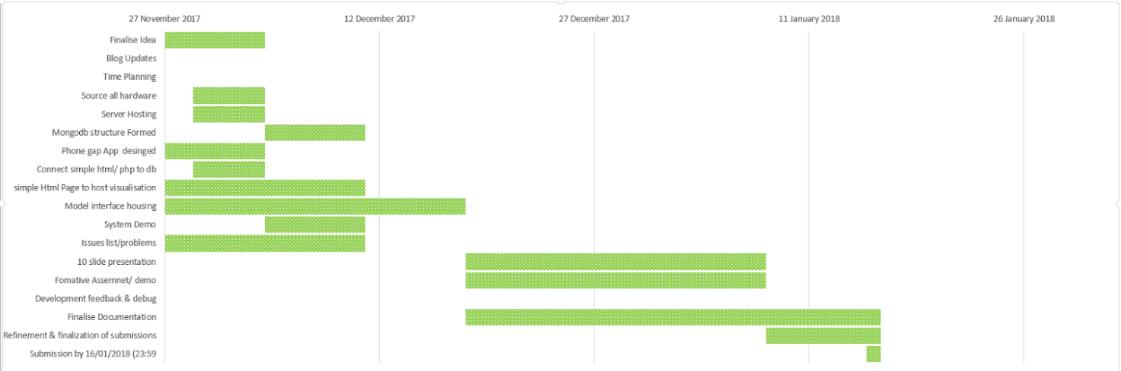

Gantt Timetable prior to new deadline (Chris Maycock 2017)

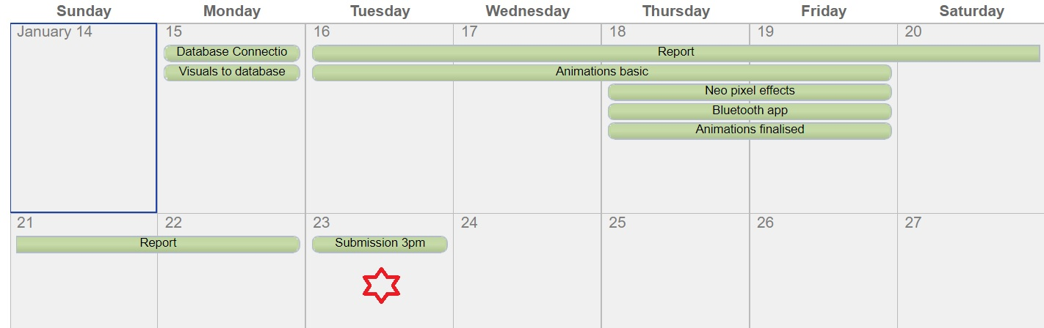

Revised deadline timetable. (Chris Maycock 2018)

|  |  |
| --- | --- |
| Resource Used | Description |
| Maker-Lab RLB205 | Assemble base |
| Brunel Stores | Materials for construction |
| Laser cutter | To make base |
| 3D Printer | To make Light diffuser |

Chris Maycock Resource list

|  |  |  |  |
| --- | --- | --- | --- |
| **Resource used** | **Description** | **Reason for use** | **Cost** |
| Raspberry Pi 3 | Raspberry Pi board | To display user interface, power touch screen and build serial connections. | (previously owned) |
| 7” Touch screen | GPIO LCD touch screen for Raspberry Pi | For user interface | (previously owned) |
| Arduino/Arduino accessories | Arduino Uno, various wires, capacitors, resistors | Wiring up of LEDs and LED rings. | (previously owned) |
| Duinopeak 24 LED ring | 24 RGB LED ring | Used for testing of head before purchasing Neopixel 24 | (previously owned) |

Stephanie Field Resource List

## 2.     Photo documentation of the projects.

### Chris

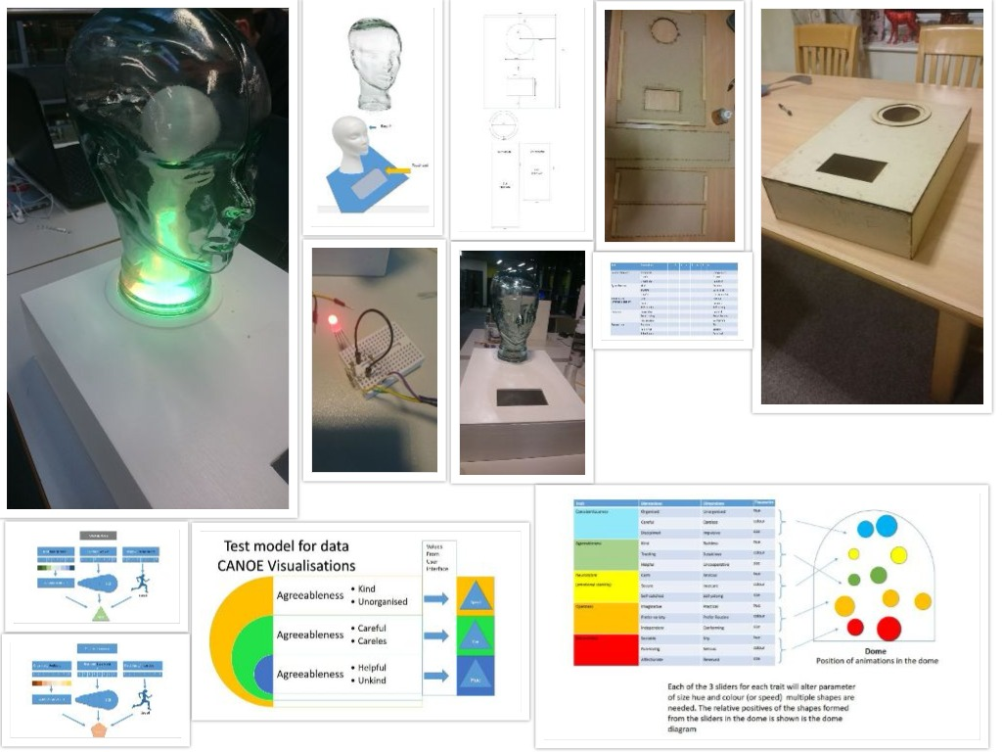

Collage of Photo record of some of Chris Maycocks progress throughout the project.

### Stephanie

### Gintare

## Project Breakdown of responsibilities

##### Group Lead

Chris - Booking group meetings, mediating between team and tutors, arranging tutorial support on technical issues, design and updating schedules, budget for build

##### Research Background

Chris -   The duties included researching how a persona might be used to generate data to use form the project and the background research for the project

Steph - Technology related research and some data visualisation background

##### System diagrams and design

Steph’ and Chris – Shared diagram generations and negotiations such as MongoDB document systems and working systems diagrams

##### Animation systems

Chris – Duties included designing and working through the theoretical systems on how animations may work

##### Animations

Gintare and Chris – duties including working together to design visualisations of data,

Gintare coding in p5.js

Gintare - data manipulation into visualisation

Gintare – matching colours to CANOE model.

##### Animation Codes

Gintare – duties included writing the code and testing within the dome.

Steph - Original css animation (butterfly)

Chris - Traffic light protype p5.js

##### Data Base and Back end

Steph’- Setting up servers (MySQL & MongoDB) & connections: enable entire read write to and from database, enable data entry to write the animations code (p5.js)

Gintate – Local Host to make a working interface

##### User Interfacing

Design – Christopher

Code - Gintare.

Data - Stephanie

##### Physical interface build and Design

Chris -  CAD, laser cutting, physical build and finishing,

Chris/ Stephanie – Bluetooth Code for Arduino

Steph - Original single LED & 24 LED ring code and Arduino wiring/build, Raspberry Pi setup (Touch screen .etc)

##### Budgets resources

Chris/ Steph - Chris build budgets, sourcing materials, LED ring, HC-05 bluetooth module for base, negotiating CAD and laser cutting times, Steph resource advising and providing Raspberry Pi/ screen.

4.     Any additional related links for your work (final website, blog links, GitHub links, etc)

##### Related Links

Shared GitHub

User Names

Chris Maycock = ChrisMbuff

Stephanie = Mustang601

Gintare = Bunbury

https://github.com/chrisMbuff/AllNetscapes

Blogs:

Chris: https://enoodl.com/2018/01/17/web-x/  
Gintare: https://mustang601.wordpress.com/category/netscapes/  
Steph: https://dreampumpkins.wixsite.com/finalyear/netscapes